**Trace Evidence Notes  
(Chapter 16)**

1. **Trace Evidence**

* _______________ evidence found at a crime scene in _______________ but _______________ amounts
* Examples:

______________________________________________________________________________

1. **Examination of Trace Evidence uses _______________**

* Microanalysis= application of a _______________ to the _______________, collection, and analysis of trace evidence
* Purpose= To determine if an _______________ of persons, _______________, and things can be made AND the _______________ of that association

1. **Instruments of Microanalysis**

1. ______________________________

* _______________ = _______________ (x) _______________

= (x)

* Amount of _______________seen/revealed is related to the _______________of the microscope . . . which is the ability to distinguish _______________ in _________ structure.

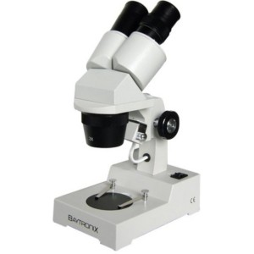

* Types of light microscopes

A. _____________________microscope

* + - * Used in _______________ evaluation of trace evidence
      * _______________
      * 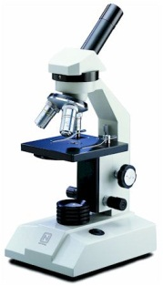Utilize _______________ light
      * View has _______________appearance

B. _______________ light microscope

* + - * Most often employed with ____________________________________illumination
      * Allows to see details of _______________ of evidence

C. _______________ light microscope

* + - * _______________to light microscope that allows for plain polarized light
      * _______________of normal light are in ____________directions (360 degrees),

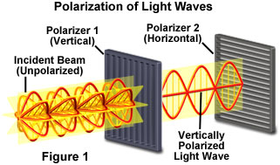but if restrict vibration to one direction,

you get plain polarized light

* + - * Can give better _______________ data

(______________ can be made more easily)

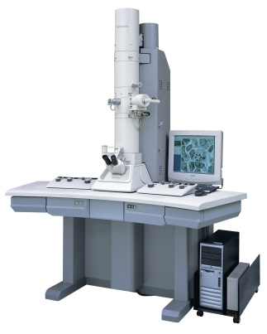2. _______________ _______________ (SEM)

* beams of _______________bounced off surface of specimen

to produce image

* can magnify much _______________light microscope

SEM has possible range of ____________

3. ______________________________

* 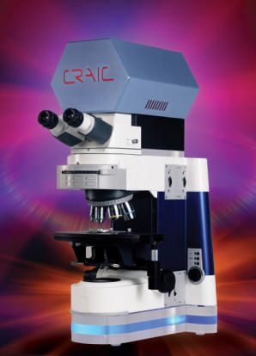Combines _______________ with a _______________ so that light absorption properties of a very small sample can be recorded
* Helps experts to determine _______________ of a sample. . . such as with fibers, hair, and painted surfaces